
ACTIVITY REPORT
On

GRE-Demystified
- Name of the club : BMSCE ACM STUDENT CHAPTER
- Name of the Activity: GRE-Demystified
- Objectives:The objective of the GRE Exam Preparation Webinar was to equip prospective test-takers with comprehensive strategies and practical insights to excel in the GRE, enhancing their readiness for graduate admissions.
- Date, Time Venue of the Activity:
Resource Person | Rohan Lakhne, Head - learning and development
TOPIC | GRE PREPARATION
DATE/DAY | Saturday, 16th march 2024
VENUE | ONLINE MODE
- Name and details of collaborating agency (if it is collaborative/joint activity): AECC Study Abroad consultancy
- Brief summary of the Programme: The GRE Exam Preparation Webinar, held online and led by Rohan Lakhne, was a highly anticipated event that drew the attention of 65 prospective GRE test-takers. With over a decade of experience in training students for GRE, GMAT, and SAT exams, Rohan Lakhne, the Head of Learning and Development at AECC, brought invaluable insights and practical knowledge to the session. His expertise and interactive teaching style kept the audience engaged throughout the two-hour seminar, providing a comprehensive overview of the GRE exam structure and its significance in graduate admissions.
The webinar was meticulously structured to cover all critical aspects of the GRE exam, beginning with an introduction to the test's format and importance. Each exam section was explored in depth: Verbal Reasoning, Quantitative Reasoning, and Analytical Writing. Rohan shared effective strategies for tackling reading comprehension, text completion, and sentence equivalence in the Verbal section. In Quantitative Reasoning, participants learned techniques for problem-solving, data interpretation, and quantitative comparisons. The Analytical Writing segment focused on crafting compelling essays, providing participants with tips to excel in both issue and argument tasks. Additionally, Rohan discussed time management techniques, study schedules, and the importance of practice tests, which are crucial for efficient preparation.
The seminar concluded with an interactive Q&A session, allowing participants to address their specific queries and concerns. This personalized interaction was highly appreciated, as reflected in the positive feedback from attendees. Participants praised the comprehensive coverage of exam topics and the practical, actionable advice provided by Rohan. The certification process, which granted certificates of attendance to all participants, added a formal acknowledgment of their commitment to preparation. Overall, the GRE Exam Preparation Webinar successfully equipped attendees with the essential strategies and insights needed to excel in the GRE, underscoring the value of expert guidance in achieving their academic goals.
- Outcomes: The seminar provided participants with a solid understanding of the GRE exam structure and effective strategies for each section. Attendees gained practical problem-solving skills and techniques to manage their study schedules and test anxiety.
- Number of participants:
Number of Faculty | Number of  Non-Teaching Staff | Number of  External Participants | Number of Students
0 | 0 | 2 | 65

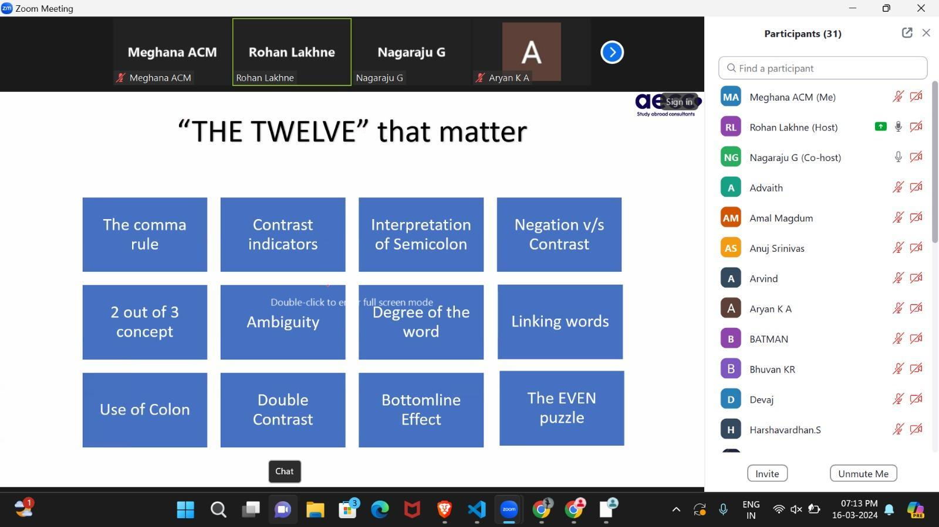
- Two or three relevant Photographs of the activity: (Geo-tagged photos are preferable)

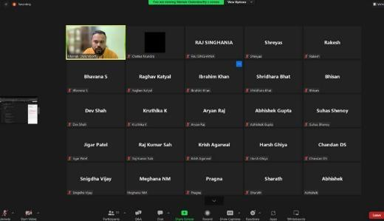

Supporting Documents
a) Attendance sheet
b) Circulars/Brochures
c) Certificates

